PRACTICAL: 2

AIM :

Semantic HTML5 Pages with Accessibility-Ready Structure
Problem Definition Develop static HTML5 skeletons for at least 10 StudentHub pages such as Home,
About, Register, Login, Dashboard, Events, Profile, Contact, Admin, FAQ, and
Feedback. Use semantic tags and accessibility-friendly structure.

1) Index.html

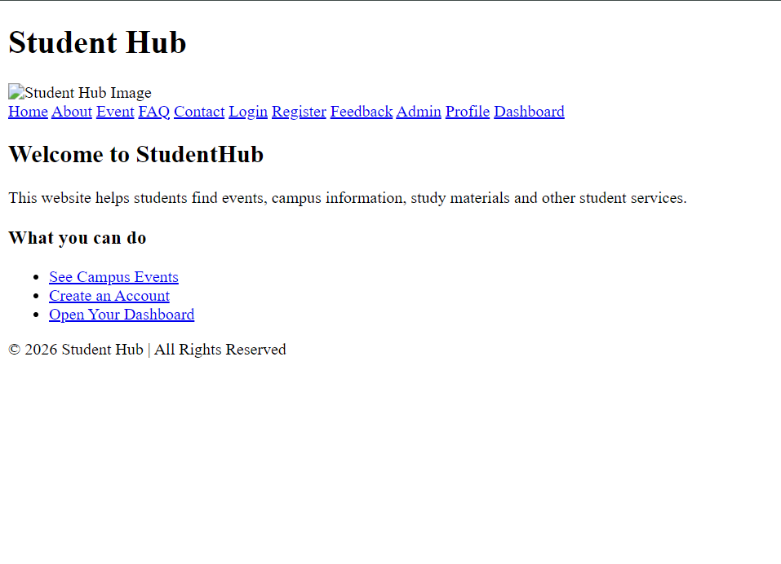

2)Register.html

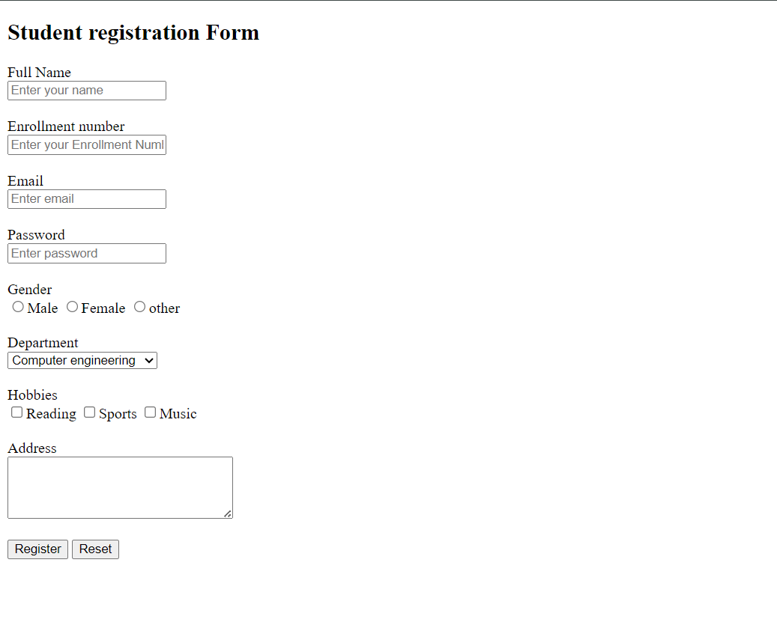

3) Login.html

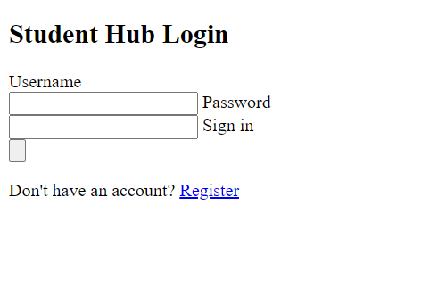

4) FeedBack.html

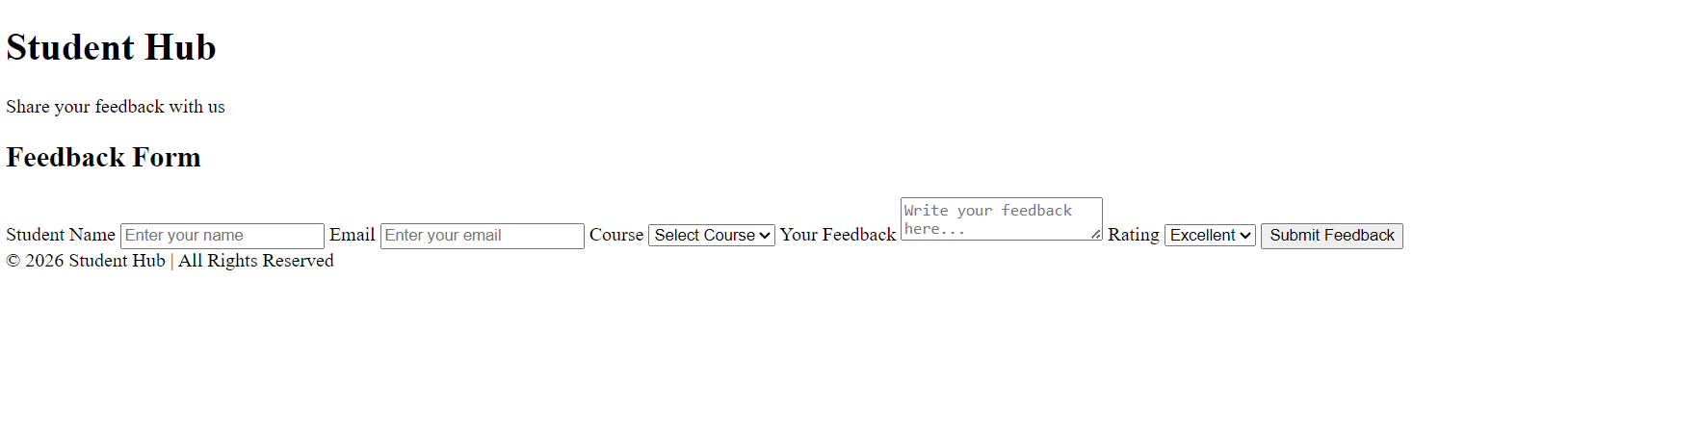

5) FAQ.html

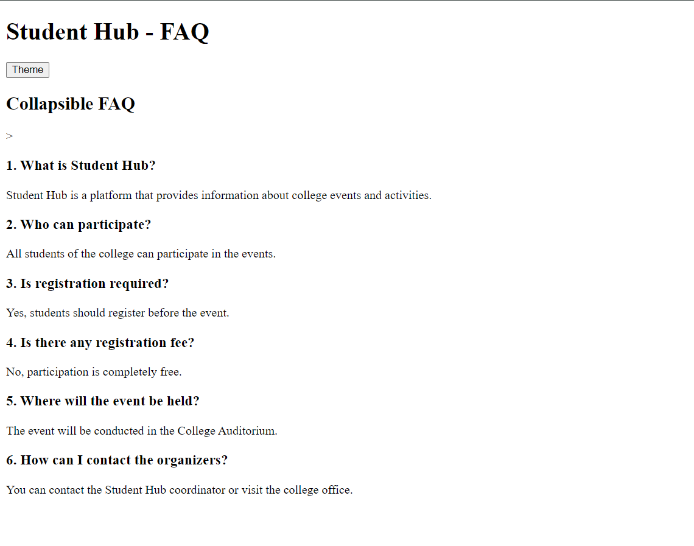

6) Event.html

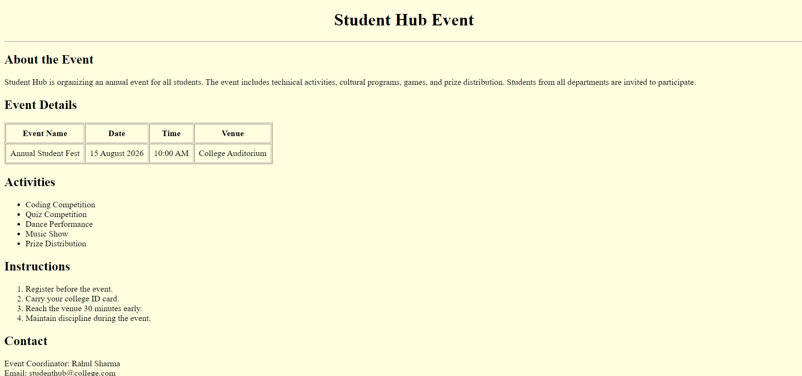

7) Dashbord.html

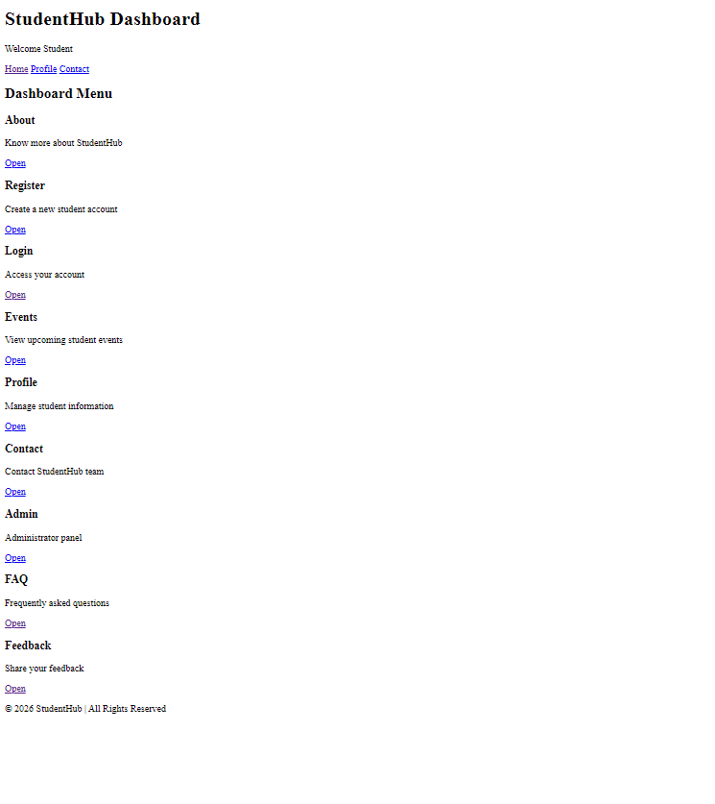

8) Contect.html

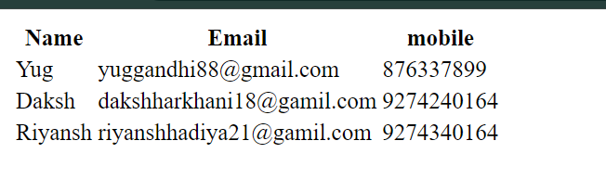

9) Admin.html

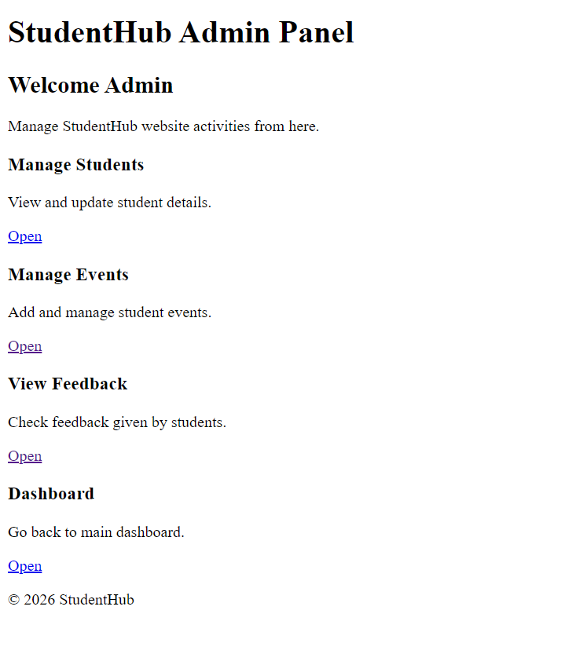

10) About.html

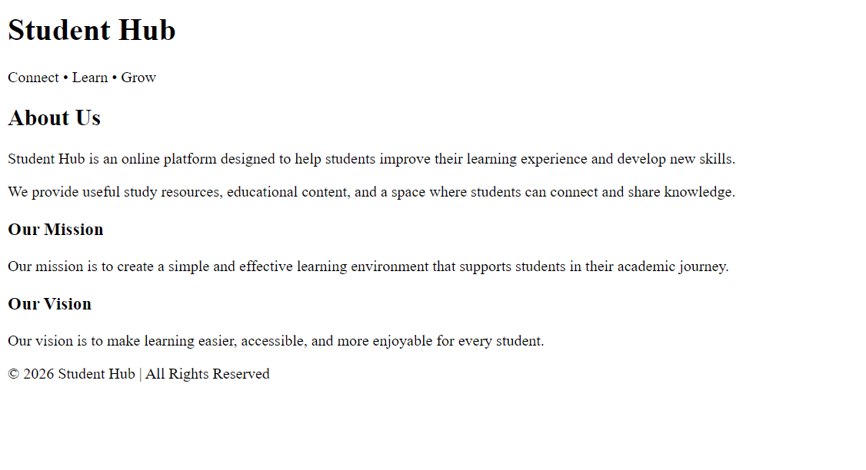

11) Profile.html

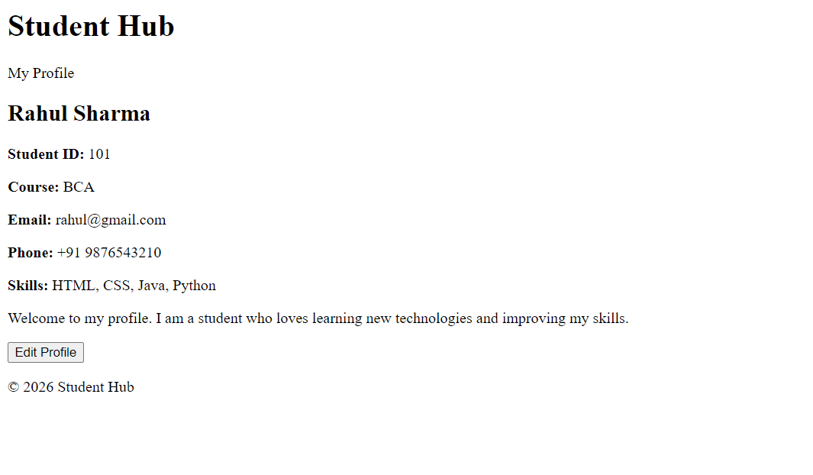

GitHub : https://github.com/25aiml013-sudo/WT_project.git

